**In this project, TMP36 temperature sensor and gas sensor are interfaced in Arduino Uno to sense the changes in the temperature and gas levels. The threshold levels have been specified in programming. The various values of the above-mentioned parameters have been given as input during the simulation process and the corresponding results were verified. If the input exceeds the threshold limits piezo-buzzer is set to alarm and LED glows.**

**COMPONENTS REQUIRED**

|  |  |  |
| --- | --- | --- |
| NAME | QUALITY | COMPONENT |
| U1 | 1 | Arduino Uno |
| D1 | 1 | Red LED |
| R2, R1 | 2 | 1 k ohm |
| GAS1 | 1 | Gas sensor |
| PIEZO1 | 1 | Piezo-buzzer |
| U2 | 1 | Temperature sensor [TMP36] |

**WORKING DIAGRAMS:**

WORKING PROCESS LINK: <https://www.tinkercad.com/things/bzYfBvv3Ah3-sizzling-vihelmo/editel?sharecode=LFimG0uygtnbfd2jbJuztnhCL4_a7sTDSRETdey_D7k>

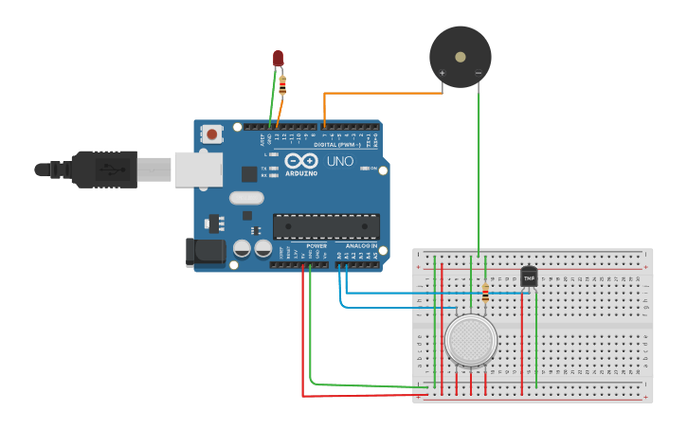

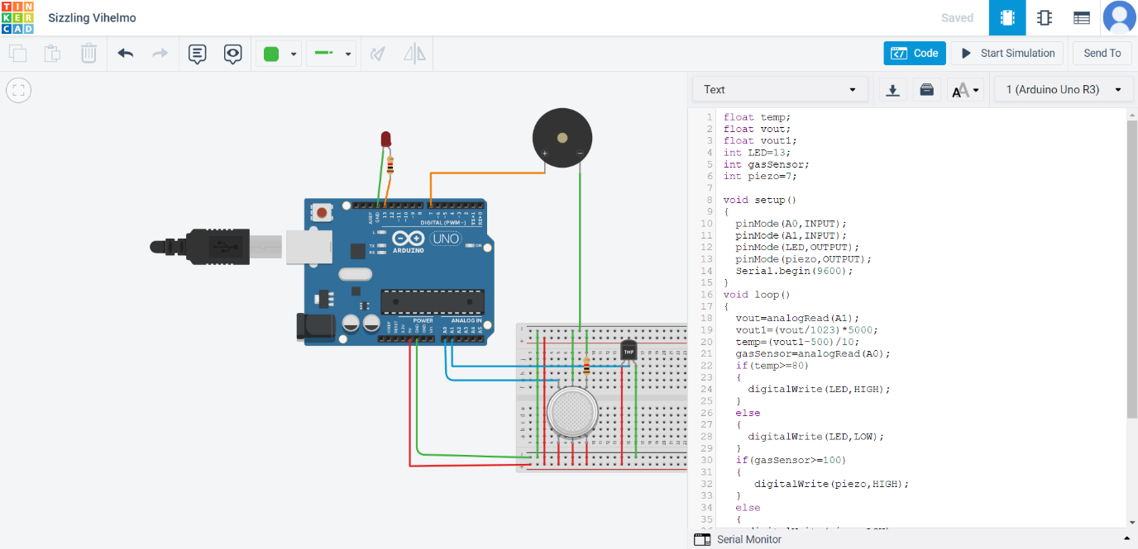

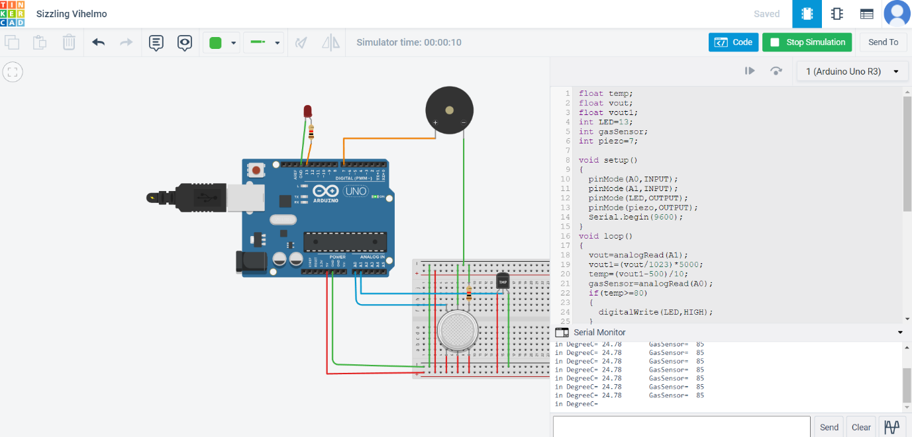

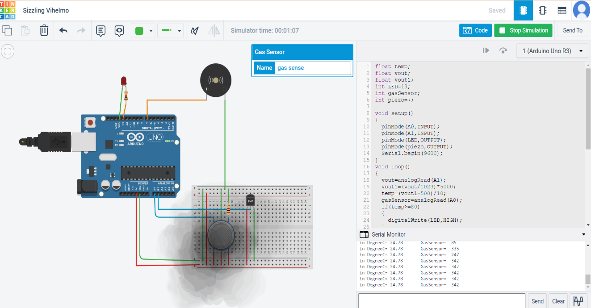

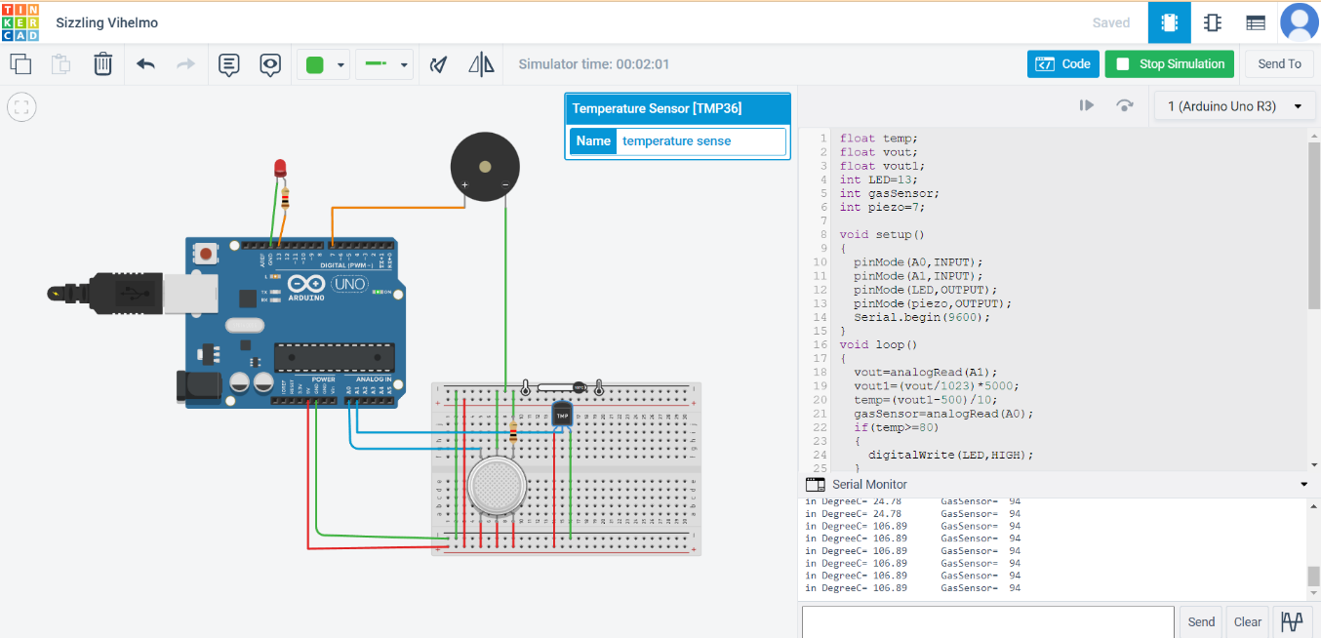

**SCHEMATIC VIEW:**

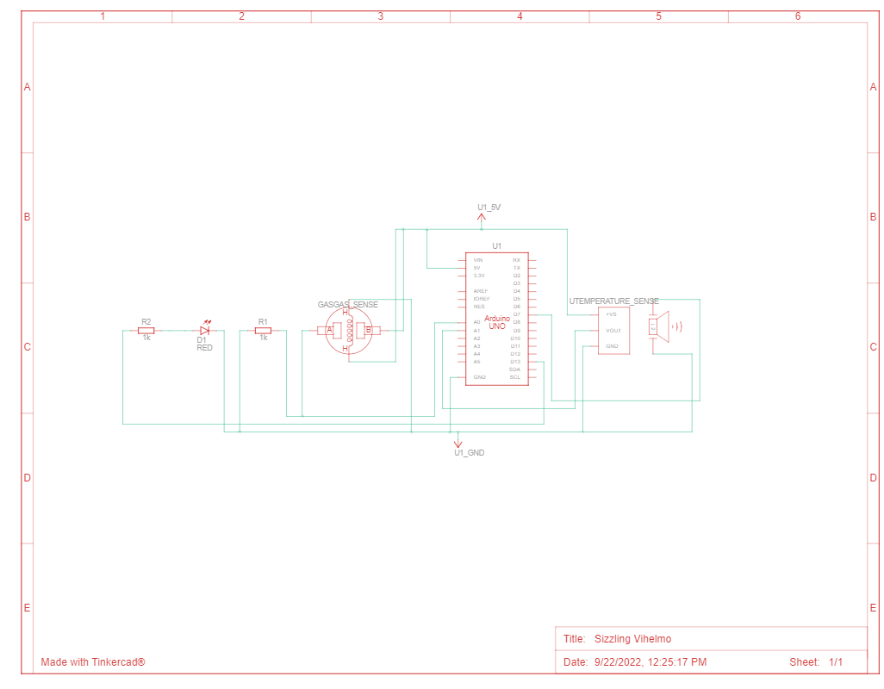

**DESCRIPTION:**

FLoat temp;

float vout;

float vout1;

int LED=13;

int gasSensor;

int piezo=7;

void setup()

{

pinMode(A0,INPUT);

pinMode(A1,INPUT);

pinMode(LED,OUTPUT);

pinMode(piezo,OUTPUT);

Serial.begin(9600);

}

void loop()

{

vout=analogRead(A1);

vout1=(vout/1023)*5000;

temp=(vout1-500)/10;

gasSensor=analogRead(A0);

if(temp>=80)

{

digitalWrite(LED,HIGH);

}

else

{

digitalWrite(LED,LOW);

}

if(gasSensor>=100)

{

digitalWrite(piezo,HIGH);

}

else

{

digitalWrite(piezo,LOW);

}

Serial.print("in DegreeC=");

Serial.print(" ");

Serial.print(temp);

Serial.print("\t");

Serial.print("GasSensor= ");

Serial.print(" ");

Serial.print(gasSensor);

Serial.println();

delay(1000);

}

**TEAM DETAILS:**

**TEAM LEADER: S MADHUVANTHHI (411419106013)**

**TEAM MEMBERS : P.GLANY ROSE(411419106008)**

**V.POOJA(411419106016)**

**R.SANGEETHA(411419106021)**